STARTERS 97

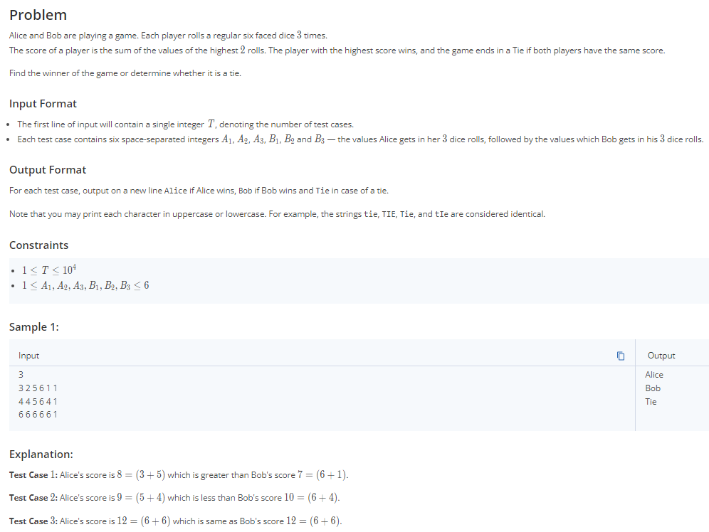

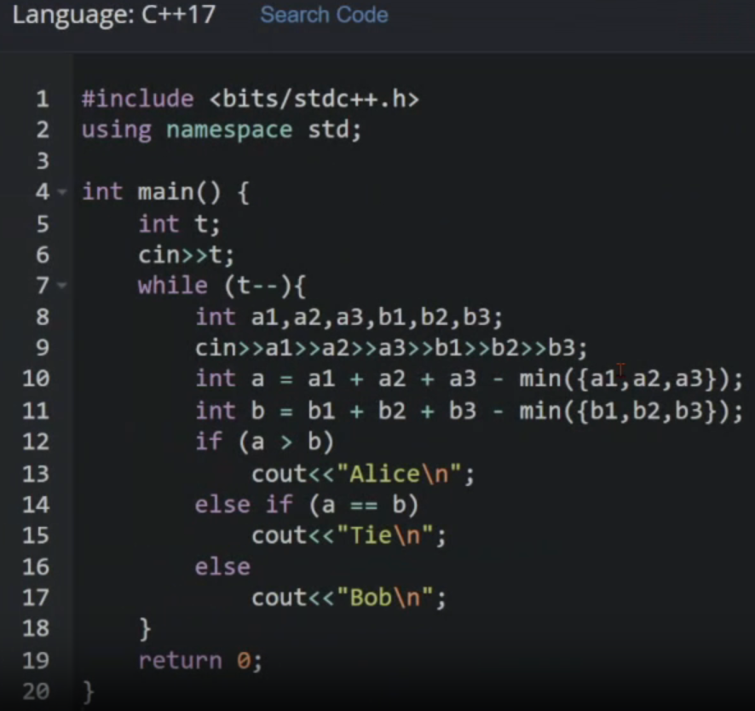

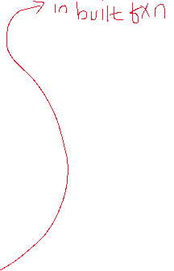

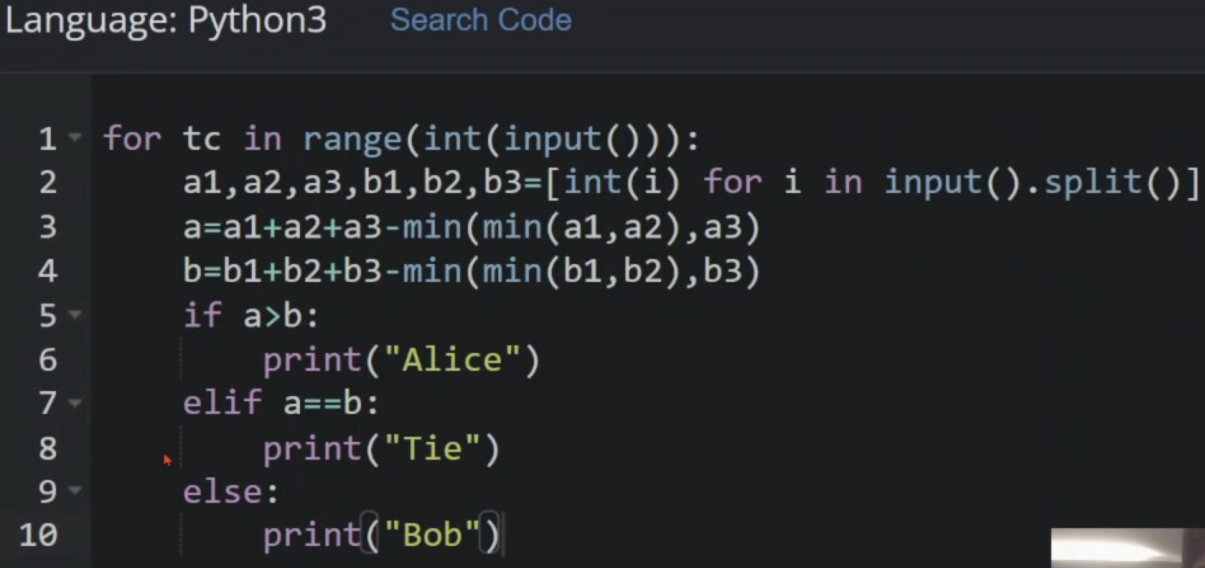



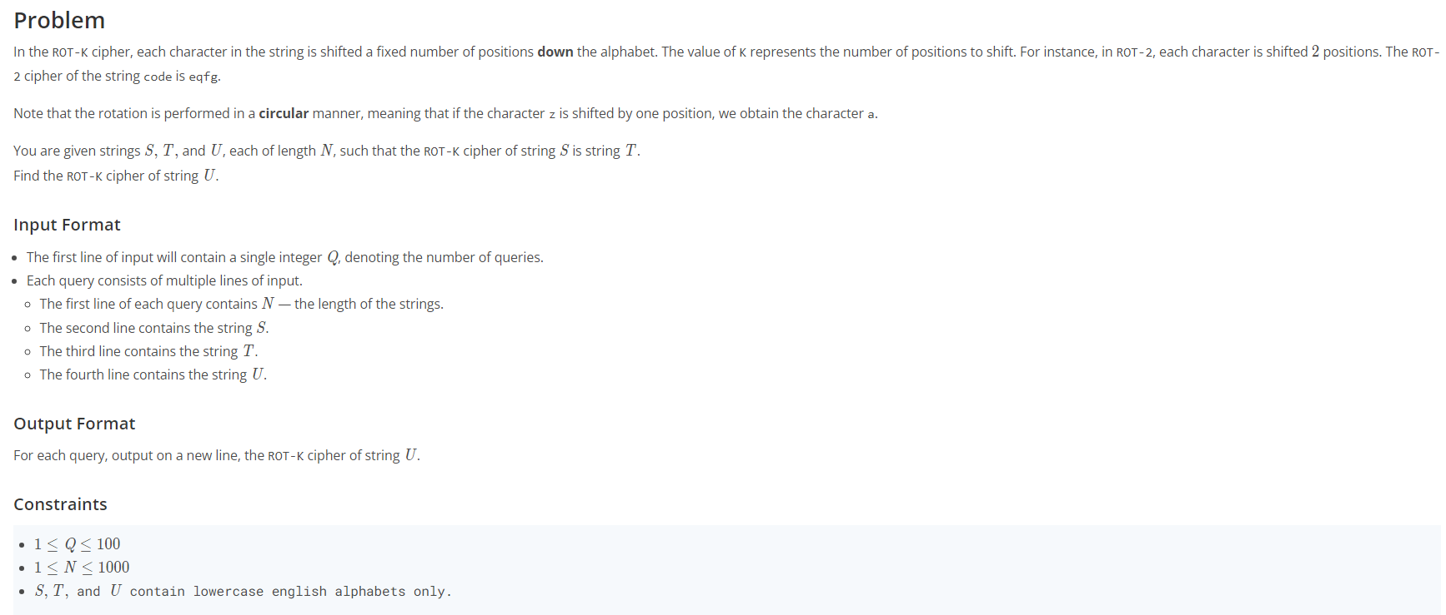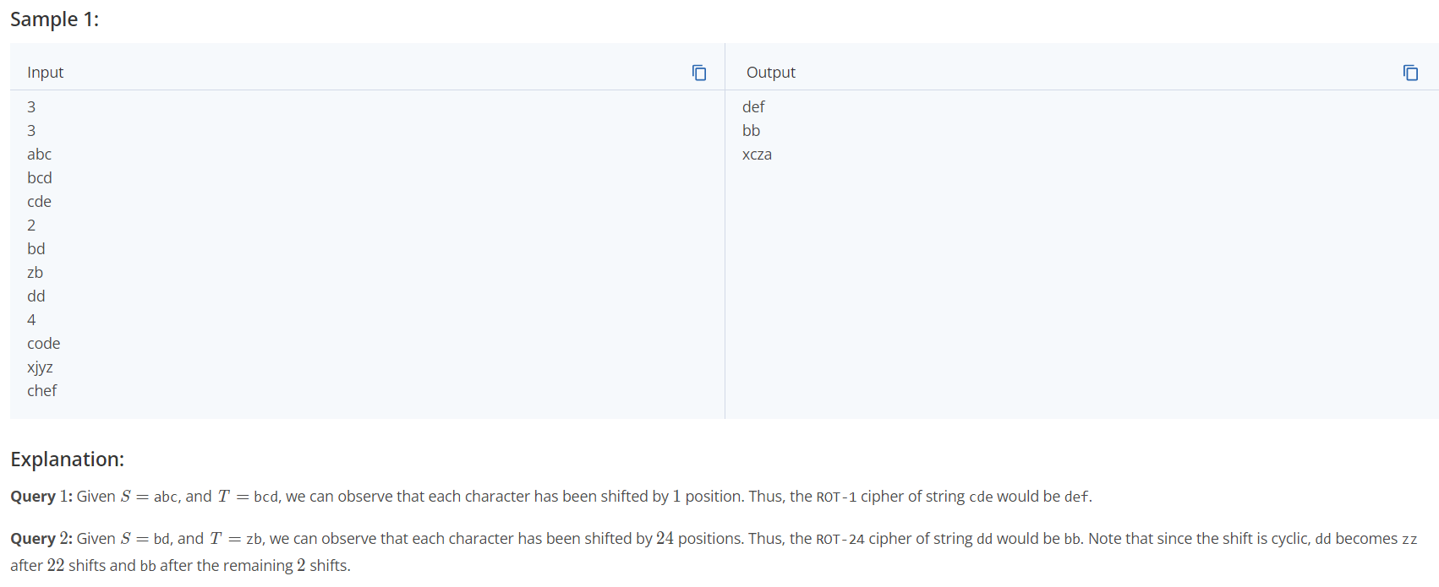



Starters 113

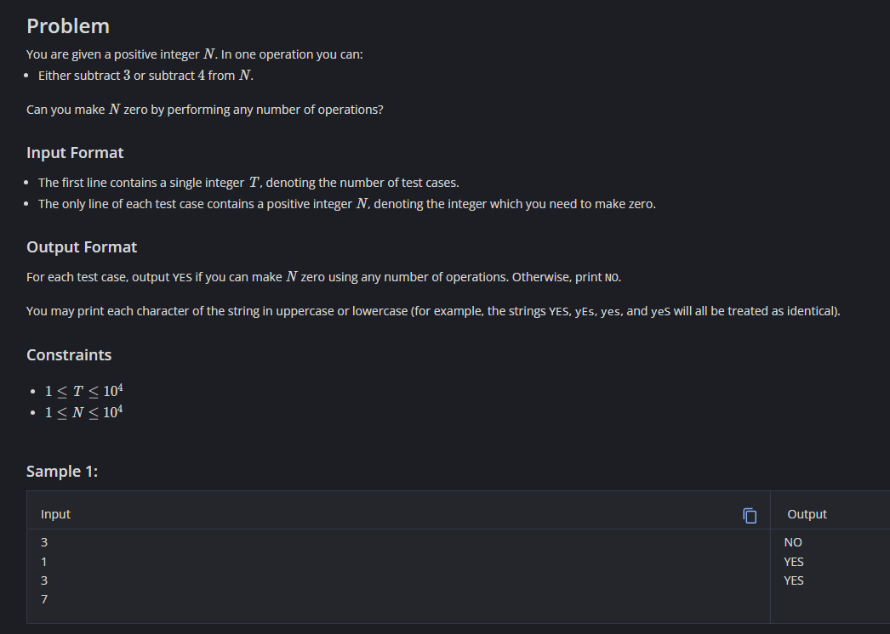 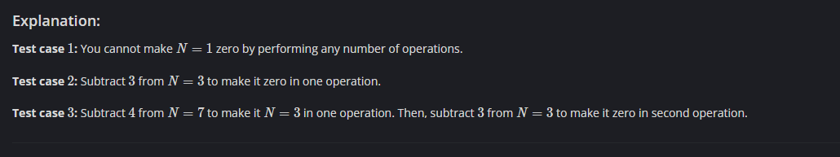

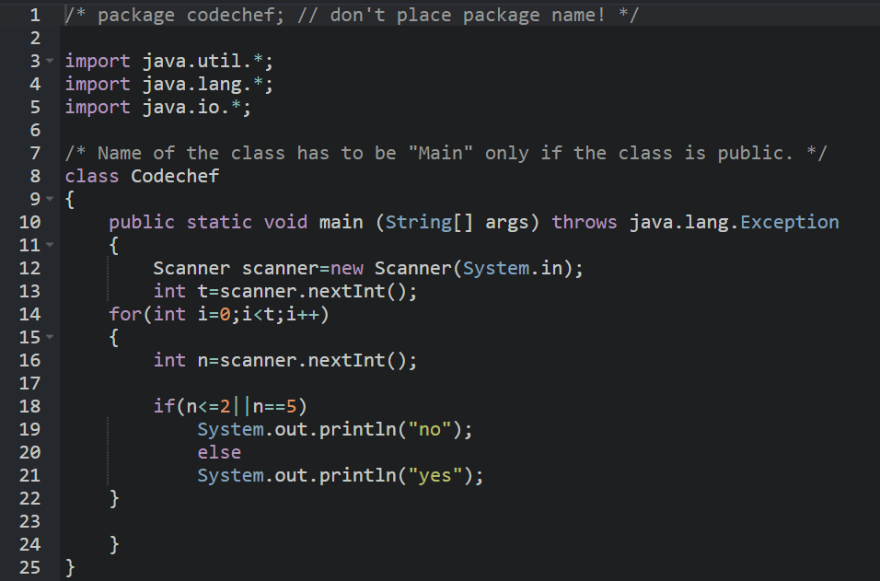

/\* package codechef; // don't place package name! \*/

import java.util.\*;

import java.lang.\*;

import java.io.\*;

/\* Name of the class has to be "Main" only if the class is public. \*/

class Codechef

{

public static void main (String[] args) throws java.lang.Exception

{

Scanner scanner=new Scanner(System.in);

int t=scanner.nextInt();

for(int i=0;i<t;i++)

{

int n=scanner.nextInt();

if(n<=2||n==5)

System.out.println("no");

else

System.out.println("yes");

}

}

}

Another method (very important to understand)

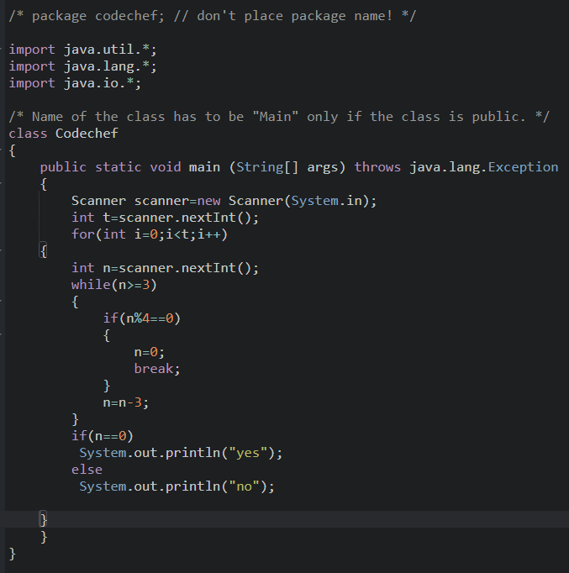

/\* package codechef; // don't place package name! \*/

import java.util.\*;

import java.lang.\*;

import java.io.\*;

/\* Name of the class has to be "Main" only if the class is public. \*/

class Codechef

{

public static void main (String[] args) throws java.lang.Exception

{

Scanner scanner=new Scanner(System.in);

int t=scanner.nextInt();

for(int i=0;i<t;i++)

{

int n=scanner.nextInt();

while(n>=3)

{

if(n%4==0)

{

n=0;

break;

}

n=n-3;

}

if(n==0)

System.out.println("yes");

else

System.out.println("no");

}

}

}